The Carer Document

Backstory

Before the game: The Carer was hired by the MC’s wife to look after the house as well as take care of the MC and the wife. The Carer knows about the MC’s condition and is aware that he will not remember her and will just have to keep her distance from him unless it’s for his medication.

During the game: At the beginning of the game (after the prologue) the MC will have smashed the house which The Carer is going around cleaning. The Carer will be trying to distract the MC from finding out his wife has died again due to him destroying the house with rage. Therefore The Carer will approach the MC when he’s working out a memory to pull his attention away and to give him his medication (pulling the player back one stage in the game).

After the game (Epilogue): The same scene occurs where the MC finds out his wife has died and ends up falling down the stairs in grief. Could have it so after the scene The Carer rushes over to try and help him which will then cut the game. This is to enforce the fact The Carer was just trying to protect the MC throughout the game.

Mechanic

The Carer is feared by the MC and vice versa. The Carer will leave the MC alone when the MC walks around the house however will approach him when he is trying to put together a memory. The Carer does this to give him his medicine (which the MC’s Wife gave The Carer the task to do) being caught by The Carer will cause the player to revert back to a previous memory. The Carer only wants to help however the player will see The Carer as someone hindering their goal to completing the game and should try preventing her reaching them whilst in a puzzle.

The Carer will walk around the house following a set path to walk on (as shown below):

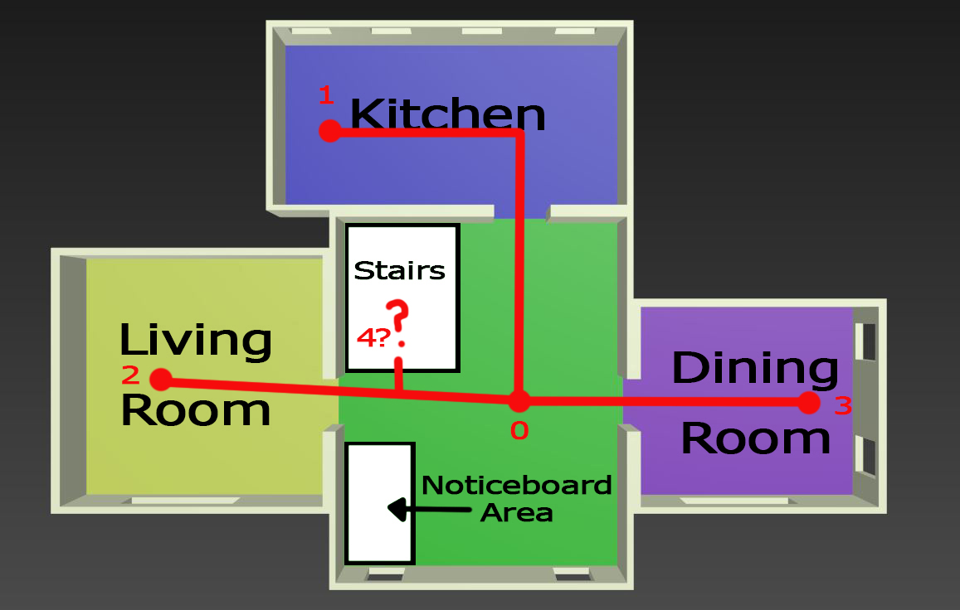

When The Carer goes to one of the rooms they will always go back to point 0 (As shown above), there they will then see if the player is in a puzzle and will then start to approach them. If the player is caught then they are reset back one memory and The Carer is placed back at point 0. If the player quits the puzzle and turns to face The Carer then she will stop and return to point 0 where she will see if the player is in a puzzle then go to a room.

Since some rooms upstairs will have puzzles later on we will include The Carer going upstairs however we will need to set what rooms the player and The Carer will have access to.

Appearance

The Carer is portrayed as a mannequin who, as the player gains more memories, becomes more human-like in detail and character. The Carer will travel around the downstairs area of the house in a circuit starting from the kitchen, going to the living room, then the dining room and back to the kitchen. The Carer’s form will be similar to a females form and so is referred to as a she.

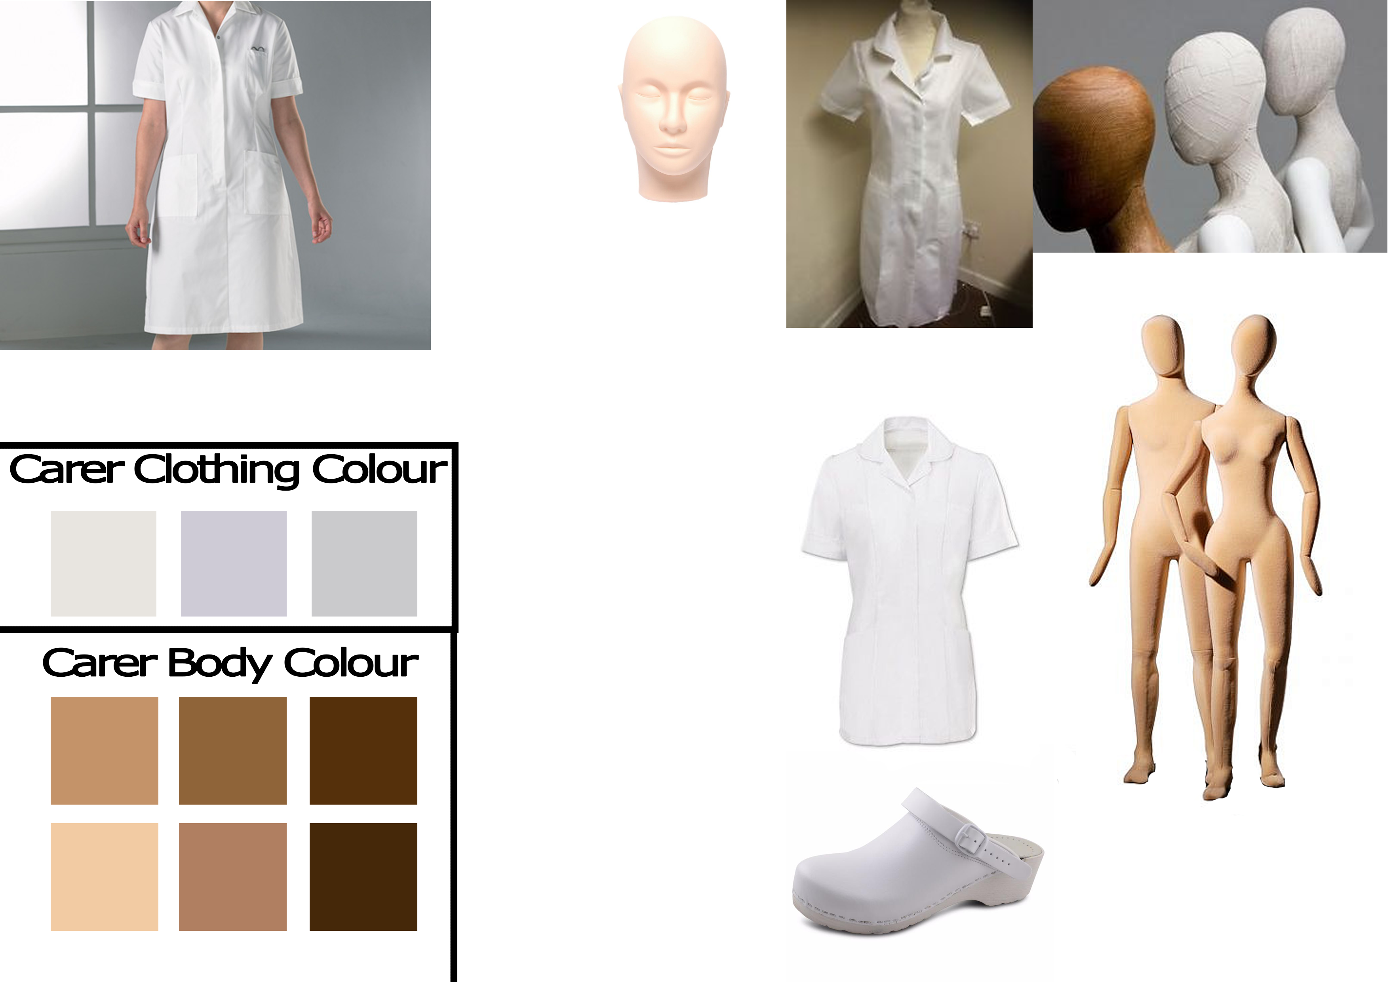

Clothing: The Carer will wear a white shirt which resembles a uniform a carer would wear, however we want to make it so the clothing has as little detail as possible to prevent players from guessing straight away that she’s a carer for the MC. The colour of the clothing will be greyscale with no patterns.

Body: Since The Carer will be in the form of a mannequin we want The Carer to have the shape of one (as shown above), therefore there won’t be much detail on The Carer. The colour scheme for the mannequin is based on wood to show the mannequin to be made of wood.

Face: The Carer’s face will start of plain and void of any facial features, however as the game progresses The Carer will start to gain subtle facial features such as a nose, mouth and eyes.